FIFA WORLD CUP ANALYSIS DASHBOARD-POWER BI
Name – Javid Akthar F
Student Code – AF04992175
Batch Code - ANP-D2495

Introduction
The purpose of this Power BI project is to analyse historical FIFA World Cup data, including matches, players, host countries, attendance, referees, and stadiums. The dashboard provides key insights and visualizations to understand performance trends, participation levels, and overall tournament statistics.
This project uses two primary datasets:
- WorldCupMatches.xlsx
- WorldCupPlayers.xlsx

Project Objectives
The main objectives of this project are:
- To visualize historical trends of attendance and participation.
- To identify the most successful countries in World Cup history.
- To explore referee involvement and stadium usage.
- To build an interactive dashboard using KPIs, charts, and slicers.

Tools and Technologies Used
- Power BI Desktop
- Microsoft Excel (Data Source)
- DAX (Data Analysis Expressions) for calculated measures
- Power Query Editor for data transformation.

Data Cleaning & Transformation
The following steps were performed using Power Query:
- Removed duplicate rows
- Standardized column names
- Changed data types (e.g., Year → Whole Number, Attendance → Whole Number)
- Removed null or irrelevant fields
- Split columns where needed (e.g., extracting City or Stadium names if required)

PROBLEM STATEMENT
- The FIFA World Cup dataset contains extensive information about tournaments, host countries, matches, goals, stadiums, and teams from various years. However, analysing this raw and unstructured data makes it difficult to understand tournament trends, team performance, hosting patterns, and match outcomes.
Key Challenges Include:
- Identifying which countries and teams have performed best across different World Cups
- Understanding year-wise trends such as total matches, goals, attendance, and qualified teams.
- Analysing which cities and stadiums hosted the most matches
- Difficulty in filtering and viewing insights by year or specific team.

Solution Statement:
To address these challenges, a comprehensive Power BI dashboard was developed that consolidates all FIFA World Cup data into a single interactive platform. The solution includes:
- Centralized Data Integration: All datasets (teams, winners, matches, stadiums, attendance, referees, goals, and host countries) are cleaned, transformed, and combined using Power Query.
- Interactive Visualizations: Bar charts, line charts, donut charts, and cards help compare winners, matches, goals, and qualified teams across different years and countries.
- Year-wise and Team-wise Filters: Slicers allow users to quickly filter the dashboard by year, team, country, or stadium for easy comparison.
- Performance Analysis: Visuals highlight trends in attendance, goals, and match counts to understand long-term patterns.
- Geographical & Stadium Insights: City-wise stadium counts and host-country information help evaluate where major tournaments were held.
- Referee & Match Insights: Referee-wise match counts help analyze decision patterns and match distribution.
- User-Friendly Reporting: The dashboard provides a unified and simplified view of all World Cup data, enabling better understanding and faster decision-making.

DAX Measures Used
KPI Measures:
- Total Players = COUNTROWS(Players)
- Total Winners = DISTINCTCOUNT (Matches [Winner])
- Total Teams = DISTINCTCOUNT (Matches [Home Team]) + DISTINCTCOUNT (Matches [Away Team])
- Overall Win % = DIVIDE ([Total Winners], [Total Teams]) * 100
Additional Measures:
- Total Attendance = SUM (Matches [Attendance])
- Total Matches = COUNTROWS(Matches)
- Unique Stadiums = DISTINCTCOUNT (Matches [Stadium])

Dashboard Design & Visualizations
KPIs (Card Visuals):
- Total Players
- Total Winners
- Total Teams
- Overall Win Percentage
Visualizations:
- Bar Chart – Total Winners by Country
  - Shows which countries have won the World Cup most.
- Pie Chart – Attendance by Year
  - Displays yearly proportional attendance distribution.
- Donut Chart – Qualified Teams by Year
  - Represents the number of qualified teams per World Cup.
- Bar Chart – Referee Count by Match
  - Identifies referees with the highest match involvement.
- Line Chart – Stadium Count by City
  - Shows stadium distribution across hosting cities.
Slicers (Filters):
- Year
- Country
- Stadium

Screenshot
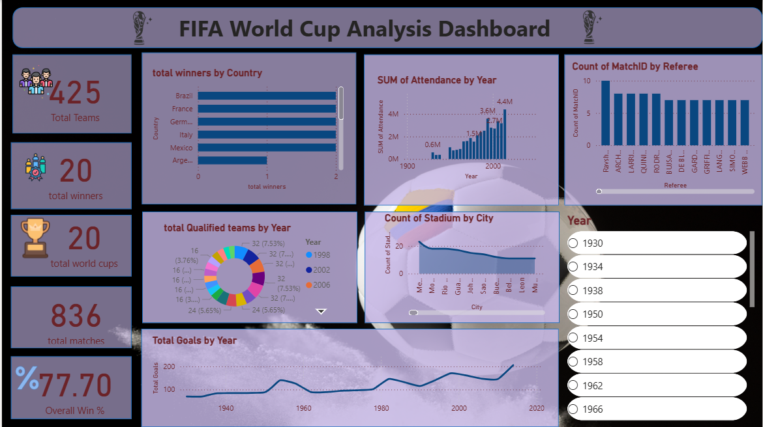

Conclusion
This Power BI dashboard provides a comprehensive analysis of FIFA World Cup history. It enables easy exploration of match trends, attendance, player statistics, stadiums, and country performance. The insights generated support deeper understanding of global football patterns and help highlight the growth and transformation of the World Cup over the years.

